American International University-Bangladesh (AIUB)

Faculity Of Science & Technology



Course Title

INTRODUCTION TO DATABASE

Spring 2023-2024

Section: I

Project Name : **Birth Record Management System**

Supervised By

Juena Ahmed Noshin

Submitted By:

|  |  |
| --- | --- |
| Name | ID |
| MD. ASICKUZZAMAN | 23-50985-1 |
| ISRAT JAHAN CHOWDHURY | 23-51219-1 |
| JAFIR ISLAM SIAM | 23-50574-1 |
| MD SADMAN SAKIB SHAD | 22-49501-3 |

**Contents: Page Number**

1. Introduction 1
2. Scenario Description 2
3. ER Diagram 3
4. Normalization 4-7
5. Finalization 8
6. Shema Diagram 9
7. Table Creation 10-17
8. Data Insertion 18-20
9. Query Writing 21-25

10.Relation Algebra 26

11.Conclusion 27

**1.Introduction**

The efficient administration of birth records is crucial for many institutions and organizations, including medical facilities, governmental bodies, and legal entities, in the fast-paced world of today. A birth record management system is a centralized platform that is intended to record, preserve, and handle important data pertaining to births that take place inside a certain jurisdiction or healthcare system. It is essential to maintaining the reliability, accessibility, and integrity of birth-related data because it makes important administrative, medical, and legal procedures easier. Simplifying the tracking and documentation of births from the time of delivery till formal birth certificates are issued is the main goal of a birth record management system. Such a system seeks to replace labor-intensive, paper-based record-keeping procedures with effective, digital workflows by utilizing contemporary database technologies and information management techniques. This change not only makes data more accurate and comprehensive, but it also makes the birth registration procedure more responsive and efficient overall.

1. **Scenario Description:**

In a Birth Management System a child can be born in only one hospital whereas in a hospital many child’s can be born. A child is identified by Birth Id. The system also stores the Child name, date of birth and gender . A child can have one father and mother whereas they can have multiple children. Father and Mother are indentified by their NID respectively. Both of them has name, date of birth, contact number and blood group. A mother can be admitted into one hospital and in one hospital many mothers can be admitted. The system stores the admit and release date of mothers. A doctor delivers the child of the mother and the delivery of many mothers can be done by one doctor. The type of the delivery and delivery date is also stored in the system. A doctor is identified by the Doctor ID. License, gender, contact number and name of the Doctor is also stored in the system. A doctor can work in only one hospital and many doctors can work in a single hospital. A Hospital is identified by Hospital Code. The system also stores the name, address and contact of the hospital. After the birth, Health Status of each child is stored in the system after checkup. Health status of a child is identified by Status ID. The system stores the weight, blood group, major or minor diseases of the child if have any.

**3. ER DIAGRAM:**

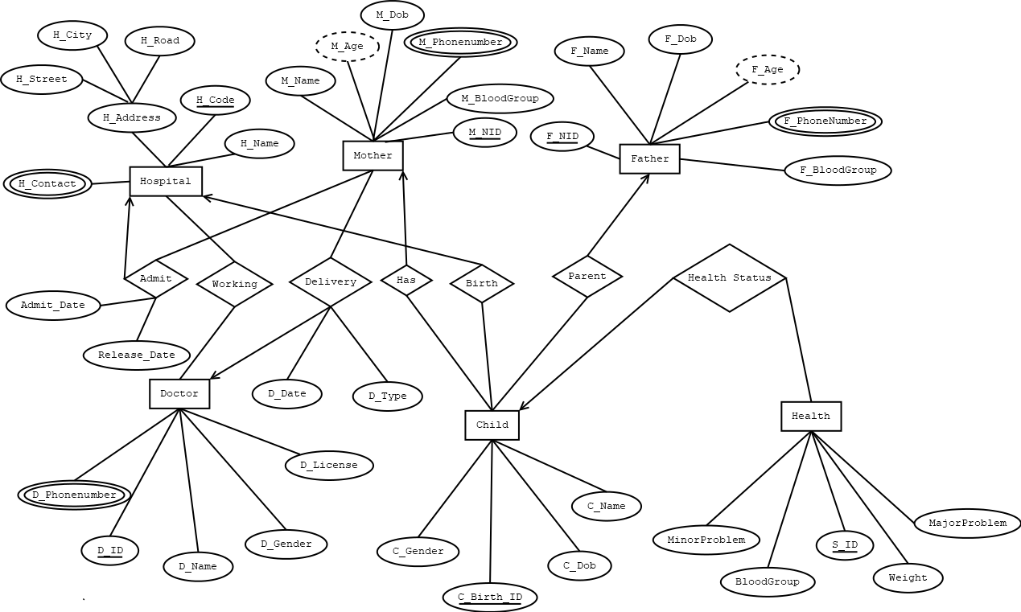**f**

**NORMALIZATION**

**Parent :**

|  |
| --- |
| UNF  Parent(F_NID,F_Name,F_BloodGroup ,F_PhoneNumber,C_Name,C_Birth_ID, C_Gender,C_Dob) |
| 1NF:  F_PhoneNumber is the mutlivalued attribute  1)F_NID,F_Name,F_BloodGroup ,F_PhoneNumber,C_Name,C_Birth_ID, C_Gender,C_Dob |
| 2NF :  1)F_NID,F_Name,F_BloodGroup ,F_PhoneNumber  2)C_Name,C_Birth_ID, C_Gender,C_Dob |
| 3NF:  There is no transitive dependancy.Relation already in 3NF  1)F_NID,F_Name,F_BloodGroup ,F_PhoneNumber  2)C_Name,C_Birth_ID, C_Gender,C_Dob |

**Has :**

|  |
| --- |
| UNF  Has ( C_Name,C_Birth_ID, C_Gender,C_Dob,M_NID,M_Name,M_BloodGroup ,M_PhoneNumber) |
| 1NF:  C_Name,C_Birth_ID, C_Gender,C_Dob,M_NID,M_Name,M_BloodGroup ,M_PhoneNumber |
| 2NF :  1)C_Name,C_Birth_ID, C_Gender,C_Dob  2)M_NID,M_Name,M_BloodGroup M_PhoneNumber |
| 3NF:  There is no transitive dependency. Relation already 3NF  1)C_Name,C_Birth_ID, C_Gender,C_Dob  2)M_NID,M_Name,M_BloodGroup ,M_PhoneNumber |

**Birth :**

|  |
| --- |
| UNF  Birth(H_Name,H_Code,H_Contact,H_Address ,H_ Street, H_City,H_Road,C_Name  C_Birth_ID,C_Gender,C_Dob) |
| 1NF:  H_Contact is the multivalued attribute  1)H_Name,H_Code,H_Contact,H_Address , H_ Street, H_City,H_Road,C_Name ,C_Birth_ID,C_Gender,C_Dob |
| 2NF:  1)H_Name,H_Code,H_Contact,H_Address ,H_ Street, H_City,H_Road  2)C_Name ,C_Birth_ID,C_Gender,C_Dob |
| 3NF:  1)H_Name,H_Code,H_Contact 2)H_Address H_ Street, H_City,H_Road 3)C_Name,C_Birth_ID,C_Gender,C_Dob |

**Admit:**

|  |
| --- |
| UNF  (M_NID,M_Name,M_BloodGroup ,M_PhoneNumber,H_Name,H_Code,H_Contact,H_Address   H_ Street, H_City,H_Road,Admit_Date,Release_Date) |
| 1NF:  H_Contact and M_PhoneNumber is the multivalued attribute    1)M_NID,M_Name,M_BloodGroup  M_PhoneNumber,H_Name,H_Code,H_Contact,H_Address   H_ Street, H_City,H_Road |
| 2NF:  1)M_NID,M_Name,M_BloodGroup ,M_PhoneNumber  2)H_Name,H_Code,H_Contact,H_Address   H_ Street, H_City,H_Road |
| 3NF:  1)M_NID,M_Name,M_BloodGroup ,M_PhoneNumber  2)H_Name,H_Code,H_Contact  3)H_Address  H_ Street, H_City,H_Road |

**Delivery:**

|  |
| --- |
| UNF  (M_NID,M_Name,M_BloodGroup  M_PhoneNumber,D_ID,D_Name,D_Gender,D_PhoneNumber,D_License,Delivery_Date,  Delivery_Type) |
| 1NF:  M_PhoneNumber and D_PhoneNumber is the multivalued attribute  1)M_NID,M_Name,M_BloodGroup  M_PhoneNumber,D_ID,D_Name,D_Gender,D_PhoneNumber,D_License |
| 2NF:  1)M_NID,M_Name,M_BloodGroup  M_PhoneNumber  2)D_ID,D_Name,D_Gender,D_PhoneNumber,D_License |
| 3NF:  There is no transitive dependency.Relation is already 3NF    1)M_NID,M_Name,M_BloodGroup ,M_PhoneNumber  2)D_ID,D_Name,D_Gender,D_PhoneNumber,D_License |

**Working**

|  |
| --- |
| UNF  (H_Name,H_Code,H_Contact,H_Address ,H_ Street, H_City,H_Road,D_ID,D_Name,D_Gender,D_PhoneNumber,D_License) |
| 1NF:  H_Contact and D_PhoneNumber is the multivalued attribute    1)H_Name,H_Code,H_Contact,H_Address   H_ Street, H_City,H_Road,D_ID,D_Name,D_Gender,D_PhoneNumber,D_License |
| 2NF:  1)H_Name,H_Code,H_Contact,H_Address   H_ Street, H_City,H_Road  2)D_ID,D_Name,D_Gender,D_PhoneNumber,D_License |
| 3NF:  1)H_Name,H_Code,H_Contact  2)H_Address ,H_ Street, H_City,H_Road  3)D_ID,D_Name,D_Gender,D_PhoneNumber,D_License |

**Health Status:**

|  |
| --- |
| UNF  (C_Name,C_Birth_ID,C_Gender,C_Dob,S_ID,BloodGroup,Weight,MajorProblem, MinorProblem) |
| 1NF:  There is no multivalued attribute.Relation is already 1NF  1)C_Name C_Birth_ID,C_Gender,C_Dob,S_ID,BloodGroup,Weight,MajorProblem, MinorProblem |
| 2NF:  1)C_Name C_Birth_ID,C_Gender,C_Dob  2)S_ID,BloodGroup,Weight,MajorProblem,MinorProblem |
| 3NF:  There is no transitive dependency.Relation is already 3NF.  1)C_Name  C_Birth_ID,C_Gender,C_Dob  2)S_ID,BloodGroup,Weight,MajorProblem,MinorProblem |

**Temporary Tables:**

1)F_NID,F_Name,,F_BloodGroup,F_PhoneNumber

2)~~C_Name,C_Birth_ID, C_Gender,C_Dob~~,**F_NID.**

3~~)C_Name,C_Birth_ID, C_Gender,C_Dob~~,**M_NID.**

1. ~~M_NID,M_Name,M_BloodGroup,M_PhoneNumber~~
2. ~~H_Name,H_Code,H_Contact,~~**~~HA_ID~~**
3. ~~HA_ID,H_Address H_ Street, H_City,H_Road~~
4. ~~C_Name,C_Birth_ID,C_Gender,C_Dob,~~**H_Code**
5. ~~M_NID,M_Name,M_BloodGroup,M_PhoneNumbe~~r,Admit_Date,Release_Date,

**H_Code**

1. ~~H_Name,H_Code,H_Contact,~~**~~HA_ID~~**
2. HA_ID,H_Address, H_ Street, H_City,H_Road
3. M_NID,M_Name,M_BloodGroup,M_PhoneNumber,Delivery_Date, Delivery_Type,**D_ID**
4. ~~D_ID,D_Name,D_Gender,D_PhoneNumber,D_License~~
5. H_Name,H_Code,H_Contact,**HA_ID**
6. HA_ID,H_Address,H_ Street, H_City,H_Road
7. D_ID,D_Name,D_PhoneNumber,D_License,**H_Code**
8. C_Name,C_Birth_ID,C_Gender,C_Dob,**S_ID**

17)S_ID,BloodGroup,Weight,MajorProblem,MinorProblem

**Final Tables:**

1)F_NID,F_Name,F_BloodGroup,F_PhoneNumber1,F_PhoneNumber2

2)C_Name,C_Birth_ID, C_Gender,C_Dob,F_NID,M_NID, H_Code, S_ID

3)HA_ID,H_Address H_ Street, H_City,H_Road

4))M_NID,M_Name,M_BloodGroup ,M_PhoneNumber1,M_PhoneNumber2,Admit_Date,

Release_Date,Delivery_Date,Delivery_Type,H_Code, D_ID

5)H_Name,H_Code,H_Contact,HA_ID

6)D_ID,D_Name,D_Gender,D_PhoneNumber,D_License,H_Code

7)S_ID,BloodGroup,Weight,MajorProblem,MinorProblem

**SCHEMA DIAGRAM**

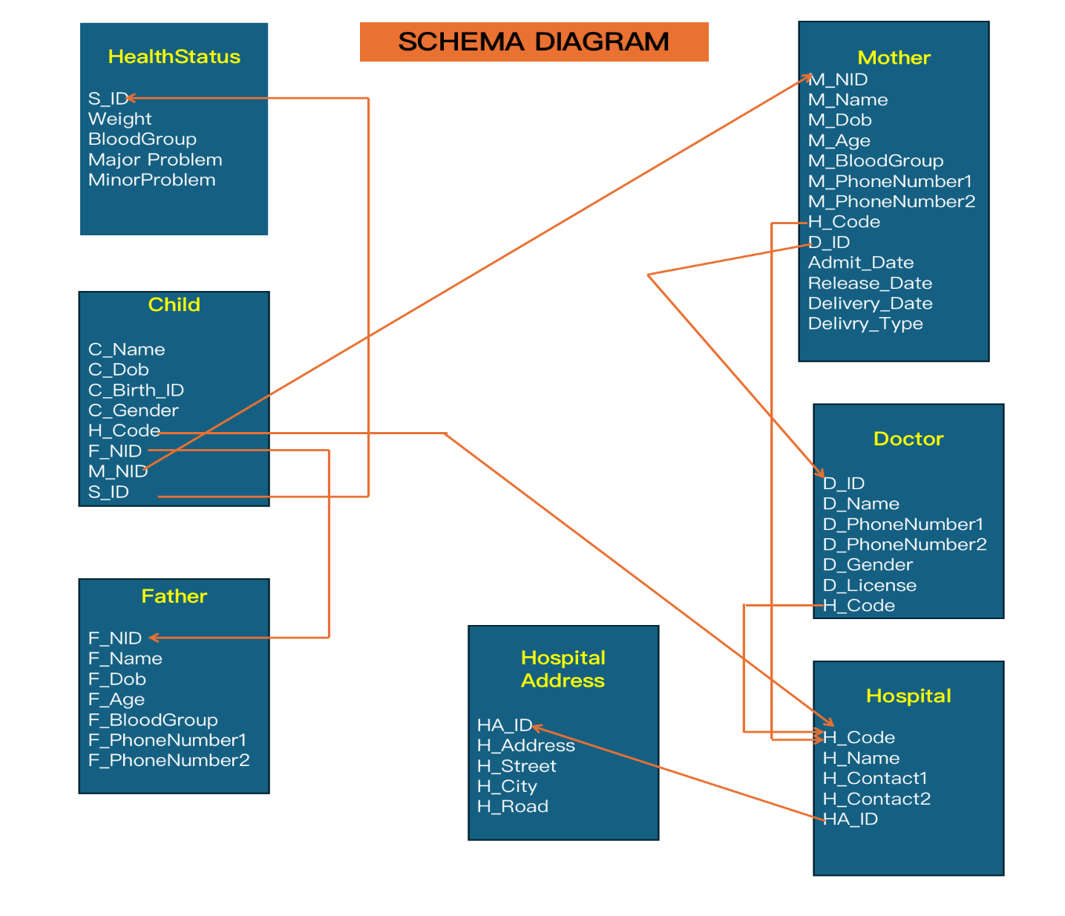

**TABLE CREATION**

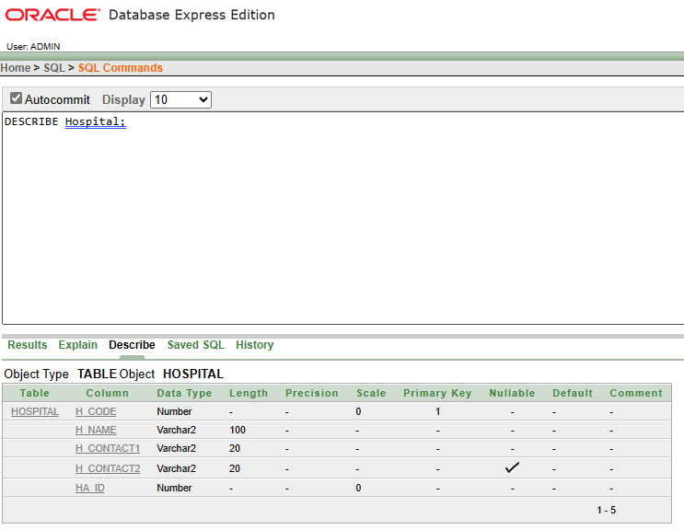

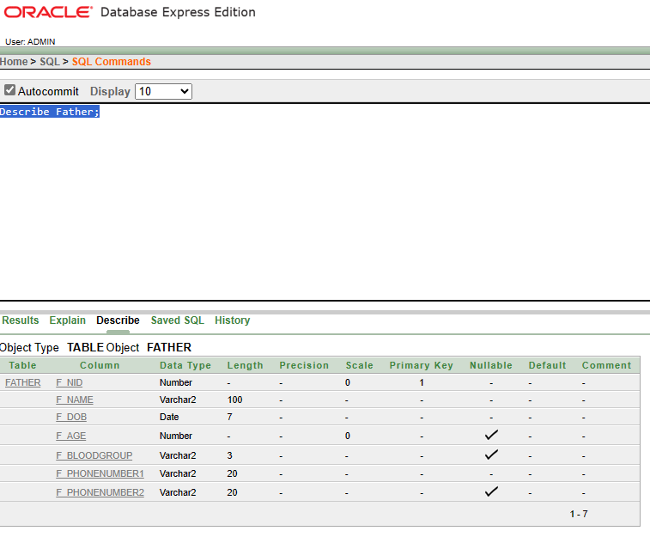

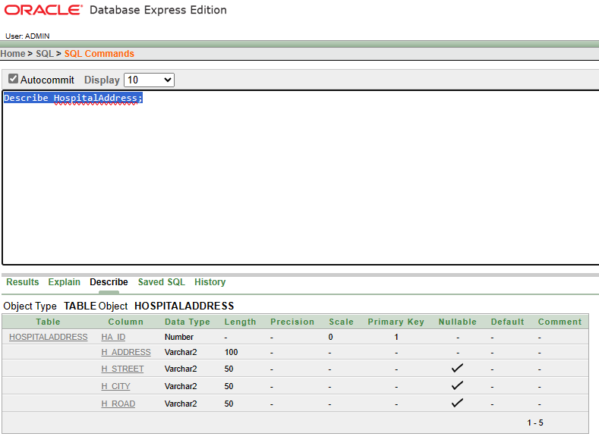

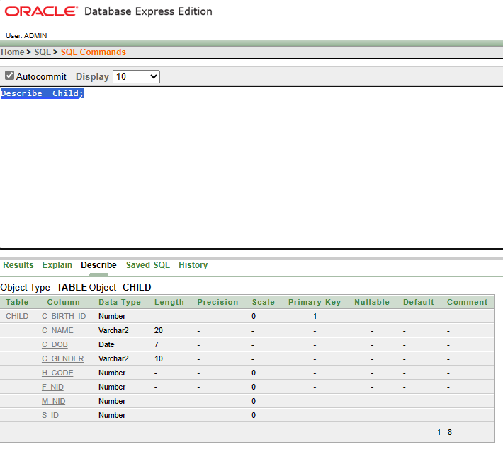 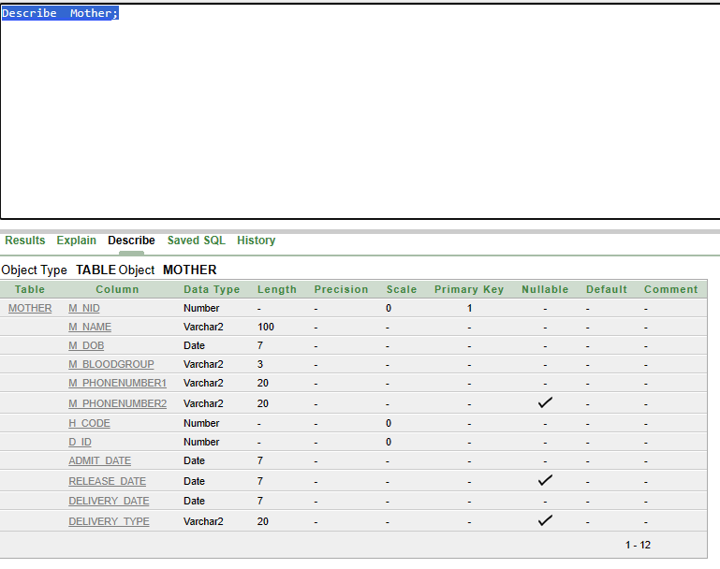 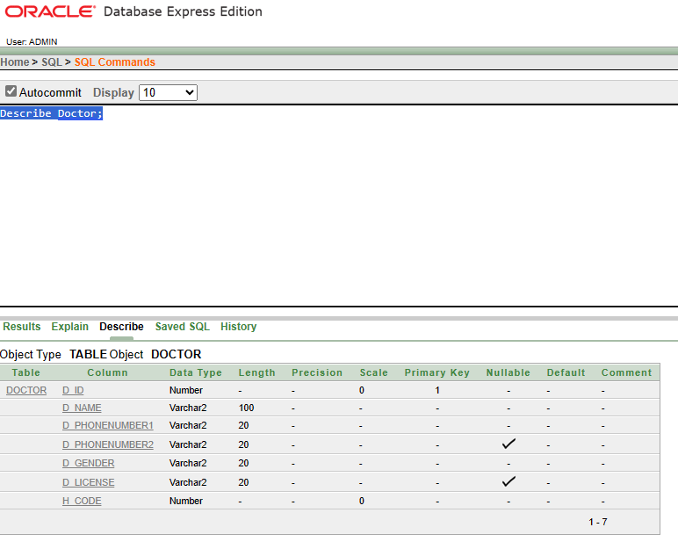

**Table creation queries:**

Create Table HealthStatus (  
    S_ID INT PRIMARY KEY,   
    Weight NUMBER(10,2) NOT NULL CHECK (Weight > 0),  
    BloodGroup VARCHAR2(3) CHECK (BloodGroup IN ('A+', 'A-', 'B+', 'B-', 'AB+', 'AB-', 'O+', 'O-')),  
    MajorProblem VARCHAR2(100),  
    MinorProblem VARCHAR2(100)  
);

Create Table Father(  
    F_NID int primary key,   
F_Name varchar2 (100) not null,  
F_Dob Date not null,  
F_Age int,  
F_BloodGroup varchar2(3) Check (F_BloodGroup In('A+', 'A-', 'B+', 'B-', 'AB+', 'AB-', 'O+', 'O-')),  
F_PhoneNumber1 varchar2(20) not null,  
F_PhoneNumber2 varchar2(20)  
);

Create Table HospitalAddress(  
    HA_ID int primary key,   
H_Address varchar2(100) not null,  
H_Street varchar2(50),  
H_City varchar2(50),  
H_Road varchar2(50) );

Create Table Hospital(  
    H_Code int primary key,   
H_Name varchar2(100) not null,  
H_Contact1 varchar2(20) not null,  
H_Contact2 varchar2(20) ,  
HA_ID int not null,  
    FOREIGN KEY(HA_ID) REFERENCES HospitalAddress(HA_ID)  
);

Create Table Doctor(  
    D_ID int primary key,  
D_Name varchar2(100) not null,  
D_PhoneNumber1 varchar2(20) not null,  
D_PhoneNumber2 varchar2(20),  
D_Gender  varchar2(20) not null Check (D_Gender In ('Male', 'Female')),  
D_License varchar2(20) unique ,  
H_Code int not null,  
    Foreign key (H_Code) References Hospital (H_Code)  
);

Create Table Mother(  
M_NID int primary key,  
M_Name varchar2(100) not null,  
M_Dob Date not null,  
M_BloodGroup varchar2(3) not null,  
M_PhoneNumber1  varchar2(20) not null,  
M_PhoneNumber2 varchar2(20) ,  
H_Code int not null,  
D_ID int not null,  
Admit_Date Date not null,  
Release_Date Date,  
Delivery_Date Date not null,  
Delivery_Time Time(0),  
Delivery_Type  boolean check (Delivery_Type In(0,1)),  
    Foreign key (H_Code) References Hospital(H_Code),  
    Foreign key (D_ID) References Doctor(D_ID)  
);

Create Table Child  (  
    C_Birth_ID int primary key,  
    C_Name varchar2 (20) not null,  
C_Dob Date not null,  
C_Gender varchar2(10) not null Check (C_Gender In ('Male', 'Female')),  
H_Code int not null,  
F_NID int not null,  
M_NID int not null,  
S_ID int not null,  
    Foreign key (H_Code) References Hospital(H_Code),  
    Foreign key (F_NID) References Father(F_NID),  
    Foreign key (M_NID) References Mother(M_NID),  
    Foreign key (S_ID ) References HealthStatus(S_ID)  
    );

**Sequence queries:**

Create Sequence Doctor_Key_Sequence  
    START WITH 1  
    INCREMENT BY 1  
    NOCACHE  
    NOCYCLE;

Create Sequence Hospital_Key_Sequence  
    START WITH 1  
    INCREMENT BY 1  
    NOCACHE  
    NOCYCLE;

Create Sequence Health_Key_Sequence  
    START WITH 1  
    INCREMENT BY 1  
    NOCACHE  
    NOCYCLE;

Create Sequence HAddress_Key_Sequence  
    START WITH 1  
    INCREMENT BY 1  
    NOCACHE  
    NOCYCLE;

New User:

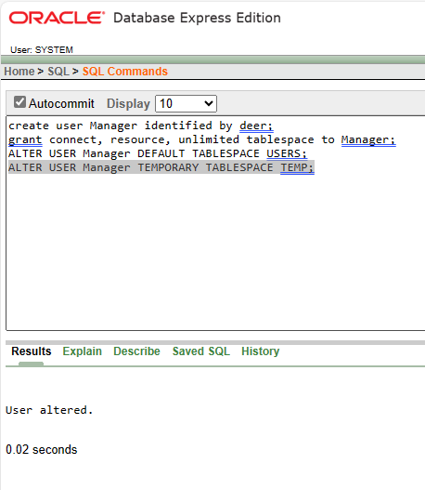

**Data Insertion**

INSERT INTO HealthStatus (S_ID, Weight, BloodGroup, MajorProblem, MinorProblem)VALUES (1, 1.5, 'A+', 'None', 'Allergy');

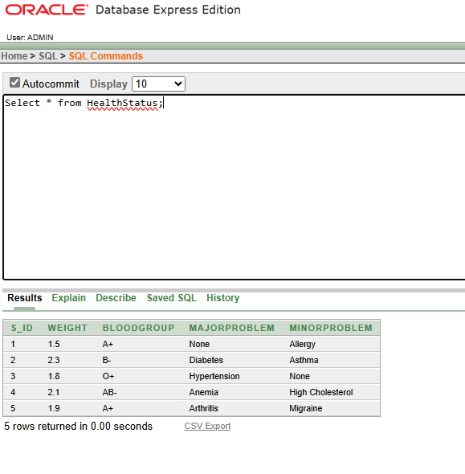

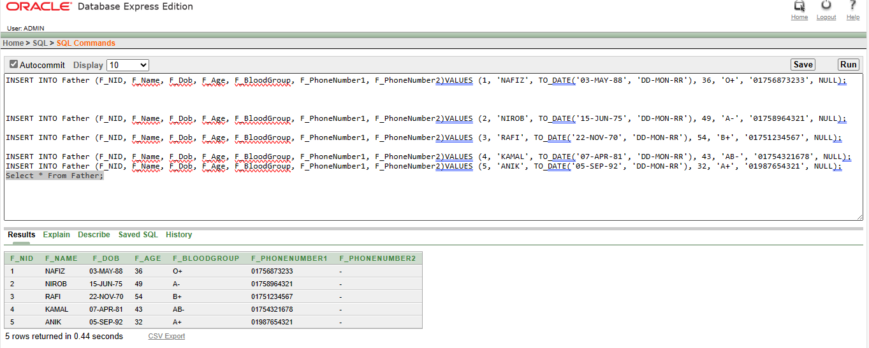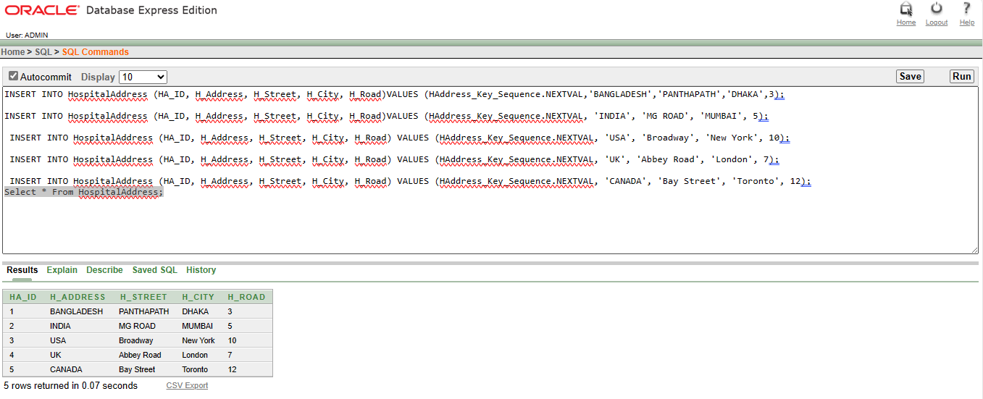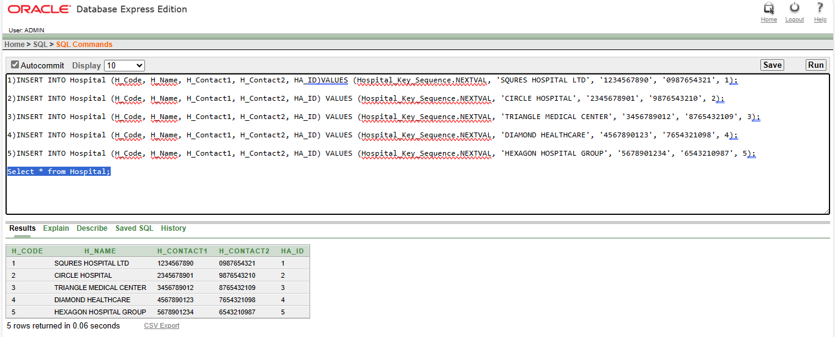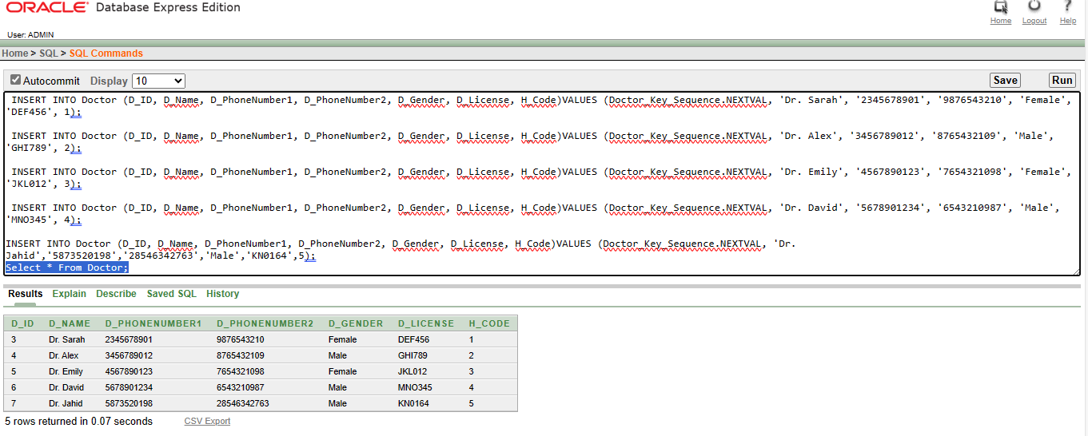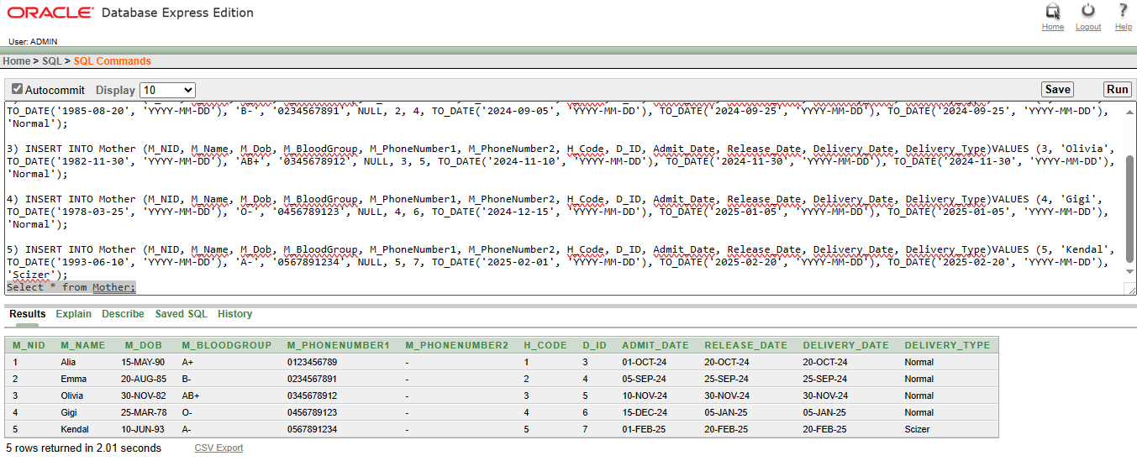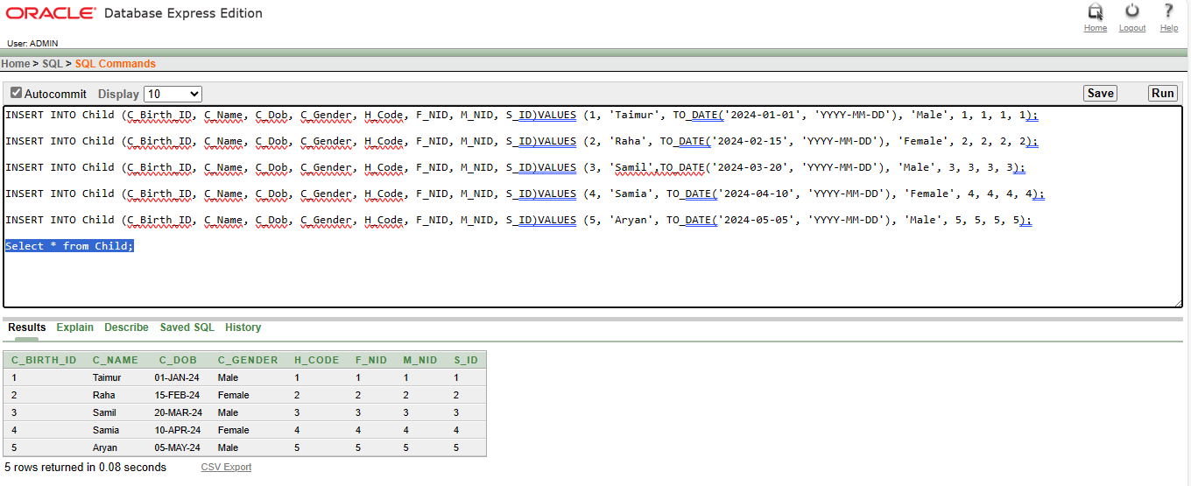

**Query Writing:**

Query 1: Single Row Function

Question: Retrieve the age of the father named 'NAFIZ' from the 'Father' table.

SELECT F_Name, F_Age,

TRUNC(MONTHS_BETWEEN(SYSDATE, F_Dob) / 12) AS Calculated_Age

FROM Father WHERE F_Name = 'NAFIZ';

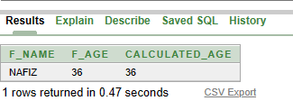

Query 2: Single Row Function

Question: Retrieve the age of the mother named 'Gigi' from the 'Mother' table.

SELECT M_Name,

EXTRACT(YEAR FROM SYSDATE) - EXTRACT(YEAR FROM M_Dob) AS Calculated_Age

FROM Mother WHERE M_Name = 'Gigi';

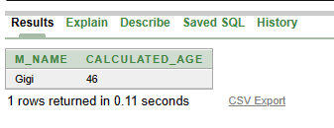

Query 3: Group Function

Question: Calculate the average weight of all children.

SELECT AVG(Weight) AS Average_Weight

FROM HealthStatus;

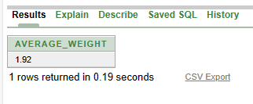

Query 4: Group Function

Question: Count the number of mothers admitted for normal delivery.

SELECT COUNT(*) AS Normal_Delivery_Count

FROM Mother

WHERE Delivery_Type = 'Normal';

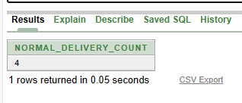

Query 5: Subquery

Question: Retrieve the names of the children born in hospitals located in India.

SELECT C_Name

FROM Child

WHERE H_Code IN (SELECT HA_ID FROM HospitalAddress WHERE H_Address = 'INDIA');

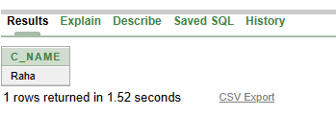

Query 6: Subquery

Question: Retrieve the names of the doctors working at hospitals where children with major health problems are born.

SELECT D_Name

FROM Doctor

WHERE H_Code IN (SELECT DISTINCT H_Code FROM Child WHERE S_ID IN (SELECT S_ID FROM HealthStatus WHERE MajorProblem IS NOT NULL));

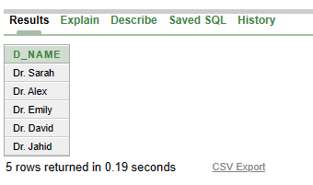

Query 7: Joining

Question: Retrieve the names of fathers and mothers along with their children's names.

SELECT F.F_Name AS Father_Name, M.M_Name AS Mother_Name, C.C_Name AS Child_Name

FROM Father F

JOIN Child C ON F.F_NID = C.F_NID

JOIN Mother M ON C.M_NID = M.M_NID;

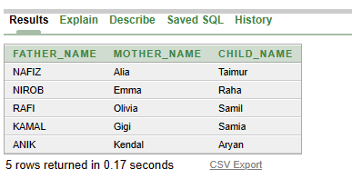

Query 8: Joining

Question: Retrieve the names of doctors along with the hospitals they work in.

SELECT D.D_Name AS Doctor_Name, H.H_Name AS Hospital_Name

FROM Doctor D

JOIN Hospital H ON D.H_Code = H.H_Code;

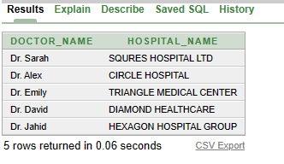

Query 9: View

Question: Create a view to display the names of mothers and their delivery types.

CREATE VIEW Mother_Delivery_View AS

SELECT M_Name AS Mother_Name, Delivery_Type

FROM Mother;

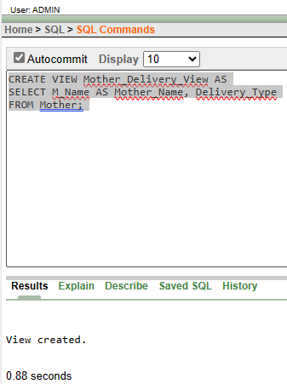

Query 10: View

Question: Create a view to display the names of fathers and their blood groups.

CREATE VIEW Father_BloodGroup_View AS

SELECT F_Name AS Father_Name, F_BloodGroup

FROM Father;

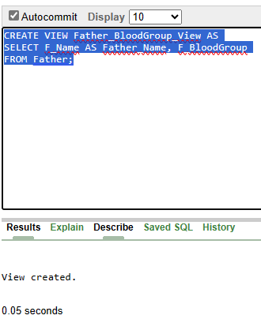

**Relational Algebra**

**Quesitons:**

1)Find the name of the child whose birth id is 4 ?

2)Find the name of the hospital whose hospital code is 5?

3)Find the hospital id whose hospital city is MUMBAI?

4)Find the delivery date where the mother name is Alia ?

5)Find the name of the mother where blood group is B+?

**Answers:**

1. ∏ C_Name(σC_Birth_ID=1(Child))
2. ∏H_Name(σH_Code=5(Hospital))
3. ∏HA_ID(σH_City=”MUMBAI”(HospitalAddress))
4. ∏Delivery_Date (σM_Name=”Alia”(Delivery))
5. ∏M_Name(σM_BloodGroup=”B+”(Mother))

**Conclusion**

To sum up, this project Birth Management System provides a strong foundation for effectively managing birth-related data in healthcare settings. The system maintains data integrity and makes it easier to retrieve and modify birth records by grouping data into distinct tables and creating relationships between entities. Future development will concentrate on creating an intuitive user interface, improving system functionality, integrating with other systems, putting data analytics skills into practice, and perhaps creating a mobile application. These improvements are intended to better the delivery of healthcare, optimize workflows, and offer insightful information to both patients and healthcare practitioners.